PHARMACY OWNER LAUNCHES THE DOSERX INDEPENDENT PHARMACY ECOSYSTEM

The DoseRx ecosystem helps independent pharmacy owners thrive by generating more revenue and greater profitability.

GENOA, IL (12 March 2018): The brainchild of Parag Maniar — a registered pharmacist and owner of two independent pharmacies — DoseRx is a healthcare ecosystem that helps independent pharmacy owners combat “the prescription reimbursement blues” due to below-cost reimbursements, and 10 years of flat net margins; and compete with large chain stores and online retailers while saving the consumer money on their prescription drugs.

With 92% of an independent pharmacy’s revenues derived from prescription drugs Parag was tired of the unpredictable PBM clawbacks, DIR fees, and other fees, so he started formulating the DoseRx ecosystem in 2015. His mission was to help local independent pharmacies survive and thrive in today’s highly competitive healthcare ecosystem by generating more profit from increased cash prescription sales, front-end product sales, and lower credit card processing fees.

In 2016, Parag started testing of the DoseRx concept by investing in a marketing campaign for the DoseRx Cash Club — a cash prescription savings program — to a retirement community of 9,000 people. It generated a 20% increase in revenue with a 5% growth in profit margin.

Using data from the NCPA 2017 Digest, that was a nearly $40,000 gain in profit for the average independent pharmacy generating $3.619 million in revenues.

Since the test, the DoseRx ecosystem has grown to include the following for the pharmacy owner: front-end product savings, a cash pricing tool, a marketing platform, and an educational resource center.

The DoseRx front-end product savings allows the independent pharmacy owner to compete with online retailer and big chain store pricing. Members will receive 30% - 70% discounts on over 10,000 front-end products and several 4-foot planograms in Health, Beauty & Wellness, Home Health Care, and General Merchandising categories.

Our front-end product savings will go a long way in helping a pharmacy achieve a 3% or more reduction in their cost of goods sold that can increase net profit by 79%, according to Upsher-Smith Laboratories, The Front-End Opportunity: Capitalizing on the Highly-Profitable Pharmacy Front-End report.

Another way a pharmacy can reduce their COGS is through lower credit card processing fees. Working with our partner, First Data, members can receive discounts on their credit and debit card processing. Considering 75% of consumers pay using credit or debit cards, a reduction in those fees can add to the pharmacy’s bottom line.

Each member will receive a free audit of their processing statements to determine the feasibility of switching from their current processor. All they need to do is send us two (2) monthly statements, and our partner will do the rest.

By using DoseRx.com as a pricing tool, member pharmacy owners can eliminate the stress of trying to price cash-based prescriptions knowing that all DoseRx members will sell the prescription at the same price and that the price will be competitive with those offered by chain drugstores without sacrificing profit margin. Furthermore, they and their staff members can quickly respond to consumer pricing inquiries.

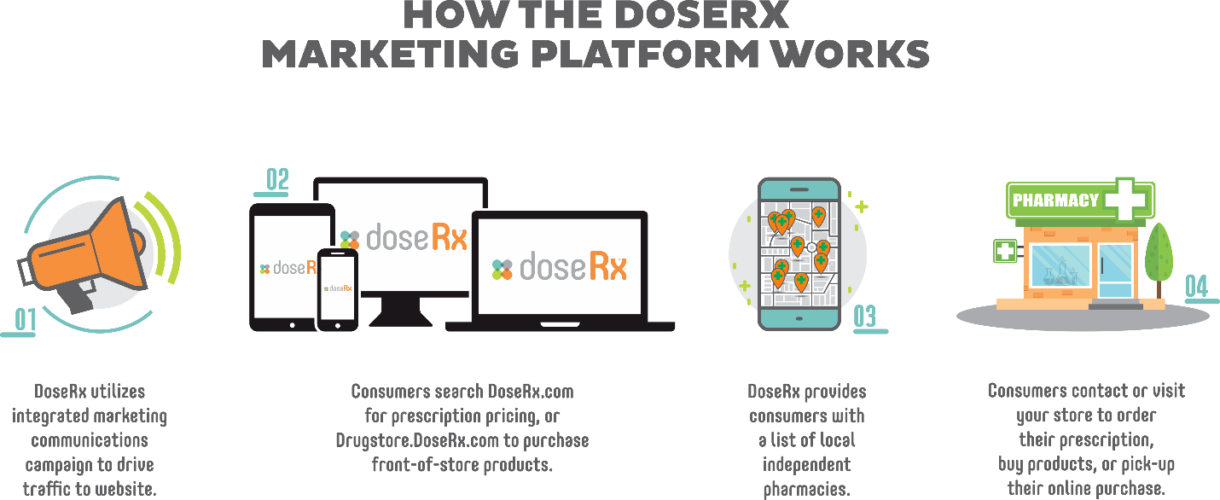

DoseRx is an integrated marketing communications platform designed to drive more consumers to your pharmacy. DoseRx will use a range of traditional and digital marketing channels to educate the consumer and drive them to the DoseRx search engine/store locator and e-drugstore. Being listed as a member pharmacy increases the likelihood of the pharmacy maintaining and expanding their consumer base.

Each member pharmacy will receive a comprehensive set of in-store marketing materials (POP displays, counter mats, employee t-shirts, window decals, tell-a-friend cards to name a few) designed to promote their DoseRx membership and to educate the consumer on the benefits of joining the DoseRx Cash Club and purchasing front-of-store products from their local independent pharmacy.

Additionally, on an a la carte or subscription basis member pharmacies, can purchase variety of marketing tools and services including, but not limited to, digital advertising design and media placement to further promote their pharmacy and DoseRx membership.

Last, but not least, DoseRx is an educational resource center. Here members will have access to a variety of educational resources like articles, videos, webinars, discussion groups and one-on-one counseling ─ all designed to help them run their pharmacy more efficiently and profitably.

DoseRx has four (4) membership packages.
DoseRx Basic is designed for pharmacies who don’t have a front-of-store operation or those who just want to earn more profit from cash prescriptions. This plan’s investment is $199 per month.

DoseRx Bronze, Silver and Gold plans are designed for full-service pharmacies who want to compete with large chains and online retailers, and generate more revenue and earn more profit from front-of-store sales along with increasing profitability through more cash prescription sales. These plans start at $299 per month.

If pharmacy owners pay annually, they’ll receive a 10% discount on the monthly subscription fee: DoseRx Basic is $2,149 and DoseRx Bronze, Silver, and Gold plans start at $3,229 annually.

For a limited time, until July 1st, independent pharmacy owners can join the DoseRx ecosystem at 50% off the monthly and annual subscription fee for the first year. The first 100 pharmacies who become members will get their 2nd year at 50% off as well.

See the DoseRx Member Plan flyer for details.

In each package, a pharmacy owner receives the following benefits when they join DoseRx.

• A basic listing in the DoseRx prescription price search engine and store locator. DoseRx Bronze, Silver, and Gold plans members also receive a basic listing in the DoseRx e-drugstore — launching soon. DoseRx Silver members receive an enhanced profile, and Gold members get a featured listing which puts them at the top of the consumer’s search results. Gold member also receive a medium rectangle ad on their profile.
• 30% - 70% discounts on over 10,000 front-end products
• Discounts on credit card processing fees
• Discounts on DoseRx Cash Club prescription processing fees for DoseRx Silver and Gold plans — putting more profit in the pharmacy owner’s pocket.
• DoseRx Bronze, Silver and Gold members earn 5% - 12% on drop-shipped consumer purchases when the consumer chooses them as the provider for their order or when the consumer orders from the member’s link to the DoseRx e-drugstore. For example, on a $50 drop-shipped purchase, the member will receive $2.50 to $6.00.

DoseRx Silver and Gold members receive a unique URL to the DoseRx e-drugstore. Members can place this unique URL on their website allowing them to have e-commerce capabilities through DoseRx ─ if they don’t have an existing capability already.
• Access to educational articles, videos, webinars, discussion groups and one-on-one counseling
• Proactive consumer marketing by DoseRx

If members follow the prescribed program, we estimate their membership fee can pay for itself with 32 or fewer, new or refill cash prescriptions per month depending on the membership level purchased, and members can add up to $300,000 in profit.

No. of NEW or REFILL Cash Prescriptions Processed Through DoseRx — Break-even Point
DoseRx Bronze Marketing Membership Plan: $299 x 0.5 x 12 = $1,794
DoseRx Average Profit per Prescription - DoseRx Transaction Fee: ÷ ($20 - $0.99) = $19.01
NEW or REFILL DoseRx Cash Prescriptions to Pay for DoseRx Membership: 96 annually or 8/mo.

With the average NCPA member pharmacy processing 191 prescriptions per day that is less than 2 prescriptions per week.

For more details, and to join the DoseRx ecosystem, contact Parag at +1 815.255.1961 or parag@doserx.com.

Media Inquiries:
Jeff Klingberg
President/CEO
Mountain Stream Group, Inc.
T +1 847.453.8895 x701
E jklingberg@mountainstreamgroup.com

